

NIHVA Technologies Pvt. Ltd.  187, G-Block, Thermax Chowk, MIDC  Chinchwad, Pune – 411019  Contact No-8551093333 /8551098333/8551091333  Email Id- sales@nihva.com ; support@nihva.com  Website-www.nihva.com | Shubhshree Engineering & Constructions Pvt Ltd.  Aurangabad  Kind Attn- Mr. Manish Sharma  Contact No-9175575106  Email Id- manishsharma@shubhshree.co.in

Project Name & Location – PH_1 Endress Hauser Flowtech Aurangabad

1.Company Profile
We

Make

Possible

“NIHVA Technologies” as one of the Pioneers in offering intelligent, innovative and integrated Automation Solutions.
We would like to work with you on your upcoming project hence request you to give us an opportunity and kindly consider our NIHVA name for Door products and Automation Solutions.
If you need more technical details about our products or any new solutions, kindly revert back to us.
“NIHVA” Business activities:
- Door Automation
- Automation Solutions & Material Handling Equipment’s (Customized)
- Water Management & Environment Solutions
“NIHVA” has always been strongly supported by world leaders in automation. Our commitment is to execute projects with highest quality, on time & within the budget,
while adhering to safety, health & environmental standards & thus we are able to serve with the best quality services and products to our customer like you.
NIHVA is the Authorized Business Partner of “ASSAABLOY” from Germany and Sweden.
Technical Specification
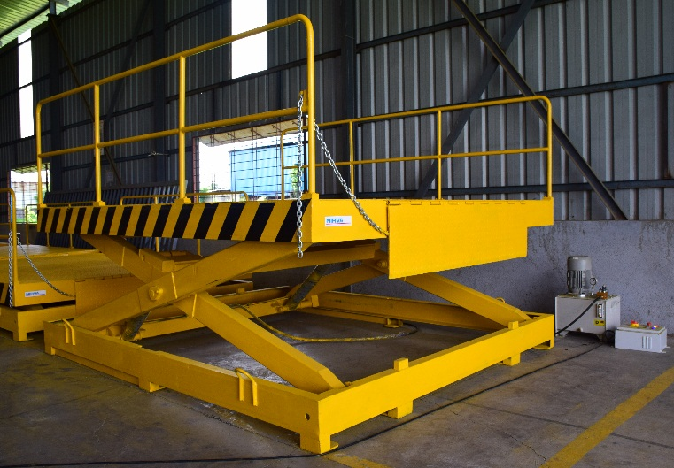
1) Pit Mounted Scissor Lift
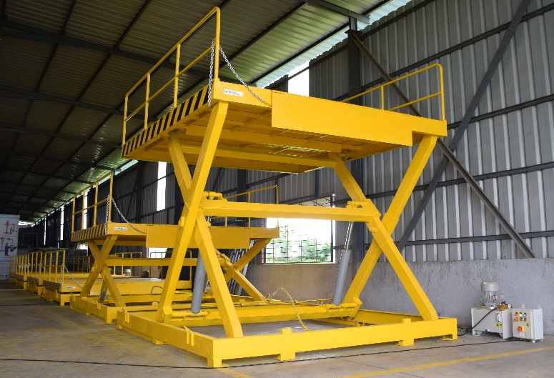

Sr. No | Description |  | Specifications
1 | Capacity |  | 6T
2 | Platform size |  | (W) 2000 mm X (L) 2500 mm
3 | Shut ht |  | 1000 mm
4 | Max ht |  | 2200 mm
5 | Lift ht |  | 1200 mm
6 | Power Pack Inside Pit with Buzzer |  | NIHVA Make
7 | Safety Railing |  | Safety railing M.S SECTION 900 mm ht all side on platform & fixed
8 | Manual Lip |  | 3 Piece (240 + 1500 + 240) - 1 Side Only
9 | Maintenance Stopper |  | 2 NOS
10 | Push Button Pendent |  | Flexible pendent with 5 Mtr Cable - 1 No
11 | Control Panel |  | Outside pit - 1 No
12 | Safety Bellow |  | All side
13 | Hydraulic Cylinder |  | Two numbers with Bore 150 X stroke 500 mm – NIHVA make
14 | Hot Dip Galvanized |  | As per IS std
15 | Hose |  | Local Make
16 | Cable |  | Polycab cables
17 | Hydraulic Oil |  | Grade 68 - 125 Ltr
18 | Paint |  | Gloosy
19 | Fabrication |  | 3500KG
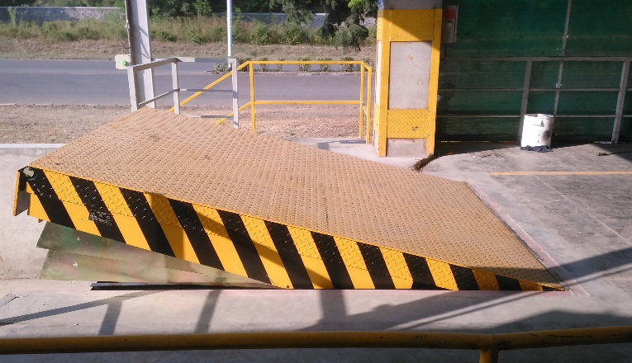
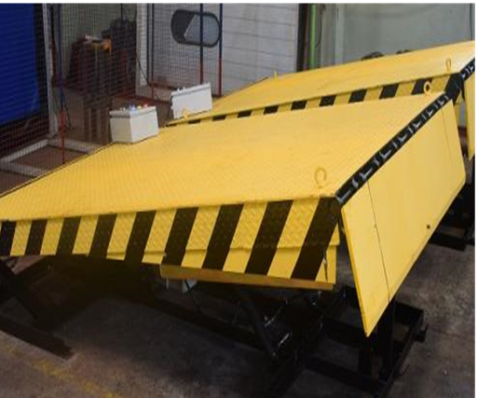
2) Hydraulic Dock Leveler

Sr. No. | Description | Specifications
1 | Capacity | 6 T (Hot dip Galvanized)
2 | Dock operation mode | AC power pack hydraulically operated
3 | Lip operation mode | Hydraulic
4 | Operation control | Through panel
5 | Loading platform height from road | 1200mm
6 | Travel above & below dock level | (+) 300 / (-) 150 mm
8 | Platform Size (W x L) | 2000 mm x 3000 mm
9 | Lip size (W x L) | 2000 x 400 mm
10 | Shut Height | 480 mm
11 | Maximum slope can be achieved | 0.1
13 | Clear Pit dimensions (W x L x D) | (W) 2050mm x (L)3000 mm x (D)480 mm
14 | Hydraulic power pack | Standard
15 | Driver type | Direct by electric Motor
16 | Motor Ratings | 1 H.P
17 | Pump design flow | 1.5 LPM
18 | Pump pressure | 120 bar Operating 200 bar Max.
19 | Safety valve set pressure | 120 Kg/cm²
20 | Pump Type | Gear
21 | Volume of oil receiver | 5 Lit
22 | No of Cylinder | 2 No for Dock & 01 Nos for Lip

3) Sectional Door

Sr. No | Description | Specification
1 | Size | (W) 4000 mm X (H) 4000 mm
2 | Vision Windows | 2 Nos at central panel
3 | Opening Direction & Mounting | Vertical (For Quantity 7 Nos)
4 | Opening Direction & Mounting | Low lift (For Quantity 1 No)
5 | Opening/Closing Speed | CDM9 0,28 m/s
6 | Door Material | GI Steel
7 | Panel Thickness | 42 mm Square Grid, steel sheet
8 | Filling | CFC-free polyurethane
9 | Panel colour | RAL 9002 Grey White Powder coated
10 | Door sealent | All door sealants made of EPDM rubber, temperature resistant -  30/+70
11 | Panel Flame Retardent standrad | Flame retardant polyurethane foam according DIN4102-class B2.
12 | Water Penetration | EN 12425 class 3
13 | Air Permealibity | EN12426 class 3
14 | Wind Load | EN21424 class 3
15 | Thermal Transittance | EN 12428 1.10W /m2K
16 | Bottom sealing | Bottom of the door to be equiped with three lip sealing made of oil resistant EPDM rubber
17 | Door saftey | Doors equiped with spring break device
18 | Incase of Power failuer | Doors to be equiped with quick release fuction
19 | Operator power conumption | Operator to have a maximum power consumption of 0,37kW and a standby consumption of Maximum 15W
20 | Drive Unit & Mounting Type | Single phase 230V direct drive on shaft
21 | Emergency Operation | by Disengagement rope manual
22 | Operating Switch | Up/Down Keypad + stopbutton
23 | Locks : Lock bolt | The Lock bolt locks the door from the inside, without the use of a key. The Lock bolt is not visible from the outside.
24 | Environmental Green Product Declaration Certification | As per ISO 14025 and EN 15804

4) High Speed Door
Sr. No |  | Description |  |  |  | Specifications
1 |  | Sizes |  |  |  | (W) 4000 X (H) 4000 mm
2 |  | Speed |  |  |  | Inverter Motion system to adjust different speeds, with progressive control of acceleration & deceleration during braking
3 |  | Security Features |  |  |  | EN 13241-1
3 |  | Opening Speed up to |  |  |  | Opening 1.5 m/s.
 |  | Closing Speed |  |  |  | 0.8 m/s.
4 |  | Control Panel |  |  |  | 4 Push Button operated
5 |  | Resistance to wind load |  |  |  | EN 12424 upto Class 2
6 |  | Curtain stabilisation / Wind load |  |  |  | Aluminium anodized windbars
7 |  | Curtain |  |  |  | Fabric -0.9 to 1.5 mm Transparent PVC section -2.0 mm
8 |  | Curtain colour |  |  |  | Standard blue RAL 5010
9 |  | Guide Material / Surface |  |  |  | Aluminium anodized
10 |  | Hood Cover |  |  |  | galvanized steel
11 |  | Motor Cover |  |  |  | galvanized steel
12 |  | Operator & Control |  |  |  | European Make Motor
13 |  | Connecting Voltage |  |  |  | 220 V ~ / 50 - 60 Hz - 1 PH , N
14 |  | Open-Stop-Close Button |  |  |  | Standard
15 |  | Protection Category (Operator / Control) |  |  |  | IP 54 / IP 65
16 |  | Power Consumption |  |  |  | 0.75 kw Motor
17 |  | Emergency Off Button |  |  |  | Standard
18 |  | Closing Zone Monitoring |  |  |  | Optical Safety edge
19 |  | External Route Monitoring |  |  |  | Photocell
20 |  | Emergency Opening |  |  |  | Crank Handle

3) Sectional Door – Ref. Photograph
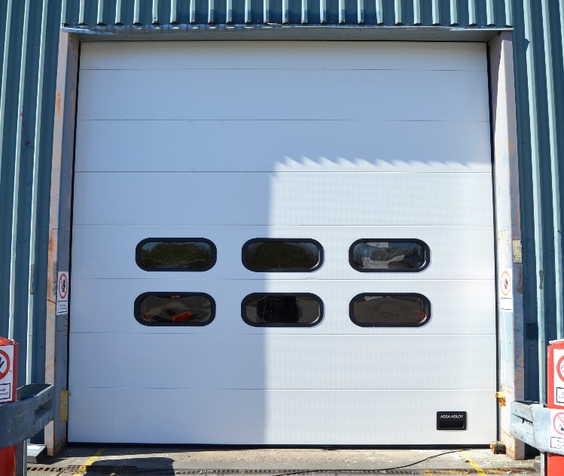
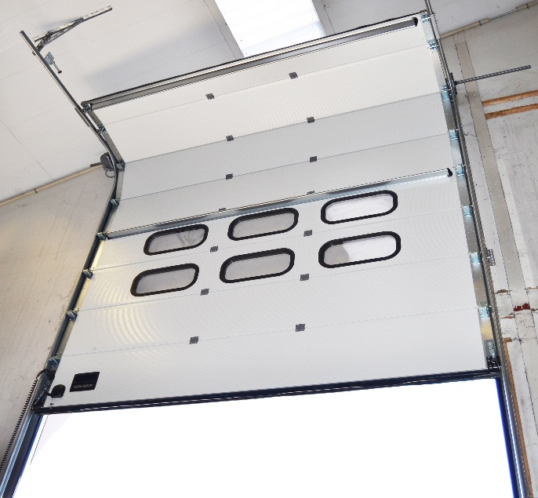

4) High Speed Door – Ref. Photograph
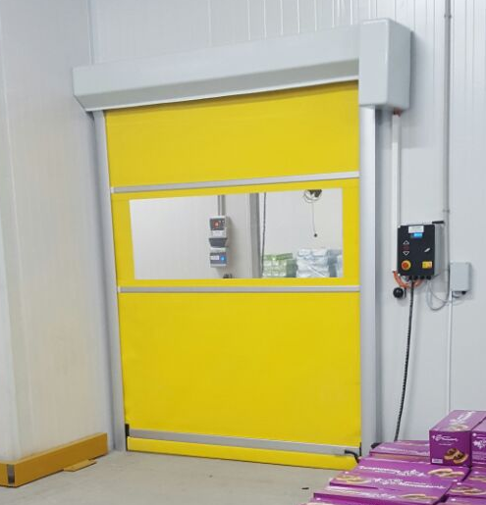
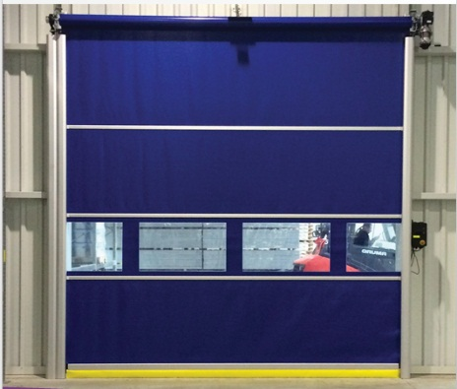

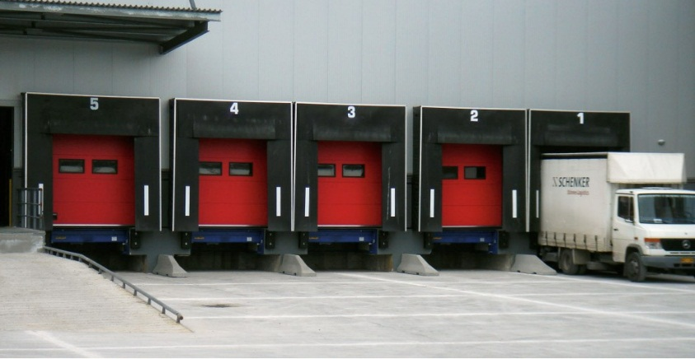
5) Dock Shelters
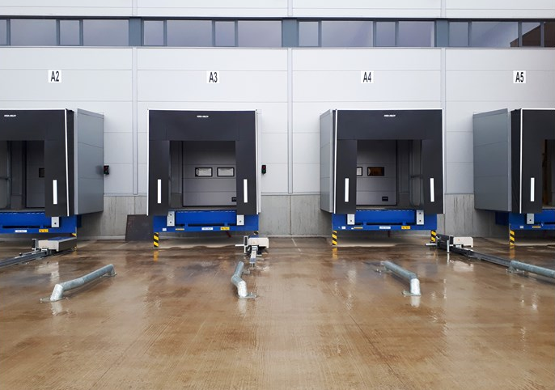

Sr. No | Description | Specification
1 | Size | (W) 3450 mm x (H) 3600 mm
2 | Quantity | 4 Nos
3 | Curtain colour | Black
4 | Parking Guides | White, Yellow
5 | Wall Fixings | Concrete, Sandwich light Concrete, Load house cavity, insulated panel
6 | Top & Side Curtaiins | Double Layer High Quality Polyester
9 | Continous Roof Cover | One layer high quality Polyester
10 | Thickness | 0.5 mm

6) Single Skinned Motorised Rolling Shutter
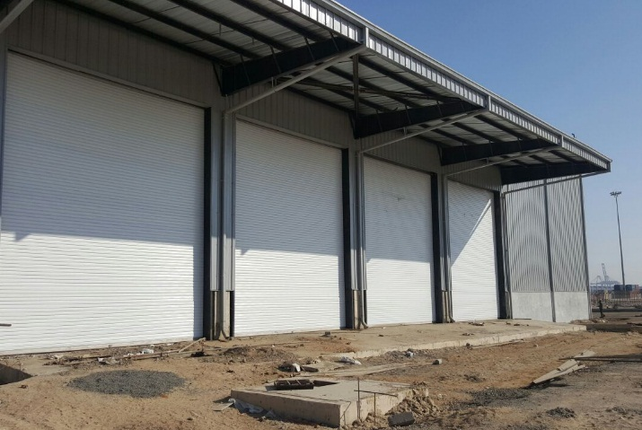
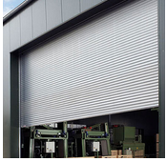

Sr. No | Description | Specification
1 | Size | (W) 2500 mm x (H) 4000 mm  (W) 4000 mm x (H) 4000 mm (perforated 600 mm)
2 | Roller shutter curtain profile type | Flat Profile GI
3 | Mounting Location area | Inside area / Outside area
4 | Mounting Surface | Side Brackets: Optional = On Concrete /Steel & Side
5 | Curtain Panel | The panel made of 1.0mm thick GI
6 | Curtain panel size | 75mm wide
7 | Bottom Profile | M. S. Plate 100 mm x 2.5 mm thick with angle stiffener
8 | Side Guide Profile | M.S." U" Shaped profile 65 mm -150 mm x 3 mm thick (as per the opening width dimension)
9 | Roller Shaft | M.S. Tubular Pipe with Flange & machined shaft at the ends Pipe Día -100 to 300 mm as per w x h
10 | Side Brackets | MS Plate 3 mm to 10 mm thick, as per the opening dimension.
11 | Hood Cover | Made of GI Sheet Thickness 0.9 mm
12 | Surface finish | without paint (Powder coated)
13 | Motor | Direct Drive European Make

